Apple Development Guide

|  |  |  |  |  |
| --- | --- | --- | --- | --- |
| Revision History | | | | |
| Version | Changes | Author | Team Name | Date |
| 1.0.0 | Initial Edit as of Xcode 5.1.1 and iOS 8 | Sara Shaffer | Centri-pedal Motion | 12/10/2014 6:00:42 PM |

Table of Contents

Preface 3

Getting Started 3

Setting up Xcode 4

Finding your UUID 4

Running Project as Simulator 5

Running Project on Device 8

Beta Testing with Test Flight 11

Creating IPA file 11

Uploading to Testflight 13

Creating a TestFlight Team 15

iOS 8 Location Services 16

Adding Icons and Splash Screen 18

Trouble Shooting 20

Linker Errors on Archive 20

Pop-up with a path name requests Location Services 22

Icons are not setting 23

Glossary 23

# Preface

Welcome to the Apple Development Guide! iOS is one of the largest mobile OS’s available. However, it is not a subject that occurs frequently in the SE program curriculum and it is often left for students to learn independently or on a co-op. Unfortunately, for newcomers to iOS development, there are some restrictions and procedures that developers must follow that might be confusing or odd to a newcomer.

Apple has provided extensive documentation but it still can be confusing and may not necessarily assist in every problem that arises. This document is written to explain the iOS development procedure in a different way and address some common problems that you may encounter.

Additionally, there is a guide to using Test Flight to beta test with your sponsor. If your sponsor is an iPhone user, Test Flight is a handy way to circumvent deploying to the App Store or you can use it to deploy a new version of your app to your phone without physically connecting your phone to a Mac.

This guide is a living document. If you find a solution on your project to a problem you think future developers may use or updates have iOS have occurred (e.g. iOS, Xcode,) feel free to update this document. Just remember to update the Revision History table before the Table of Contents.

# Getting Started

Here are some things you’ll need to get started:

A Mac computer- Yes, you *need* a Mac to do iOS development. However, the SE department was kind enough to provide Team Centri-pedal Motion with a Mac Mini in the Grad Lab which we accessed remotely through TeamViewer. If no one on your team has a Mac, ask your instructor and the system administrator for access to the Mac Mini or a similar option.

Xcode- This is the IDE for iOS development. This is available for free in the App Store. You just need an AppleID to download it.

Developer Account- You can get an Apple Developer account at (<https://developer.apple.com/>) and sign in using the Member Center link. It is highly recommended you create a new Apple ID. It currently costs $99 a year to enroll in the Developer program. Ask your sponsor if they can provide you with a Developer account.

Developer’s Code-Signing Certificate- You can attain one of these from your Team Agent. This says that a trusted team member is making changes to the code. This is needed to deploy to a device.

Provisioning Profile- This is also needed to deploy to a device. You can be added to a provisioning profile by a Team Agent. This identifies your app, who can run it, and on what devices.

iOS device- a device such as an iPhone or iPad

iOS USB cable- a USB cable to connect to the computer. iOS USB cables are usually device specific.

Test Flight desktop app- an interface to easily upload your build to TestFlight from your desktop.

# Setting up Xcode

1. Download Xcode through the Apple App Store. (You will need an Apple ID). (If you need an older version of Xcode, go to <https://developer.apple.com/downloads/index.action>, sign in using your Developer credentials, and page through until you find the version you need.)
2. Point to [sudo] xcode-select -switch /Applications/Xcode.app/Contents/Developer

# Finding your UUID

1. Connect your device to your computer
2. Open iTunes if it does not open automatically
3. Click on your device’s name

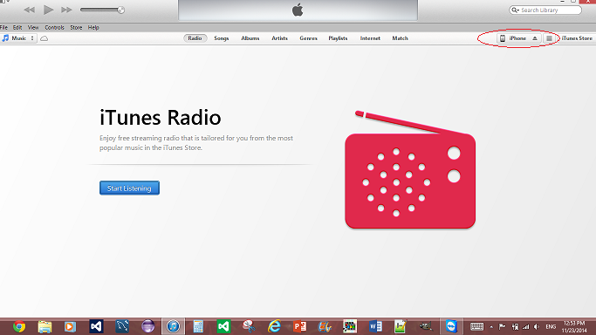

1. Look the Summary

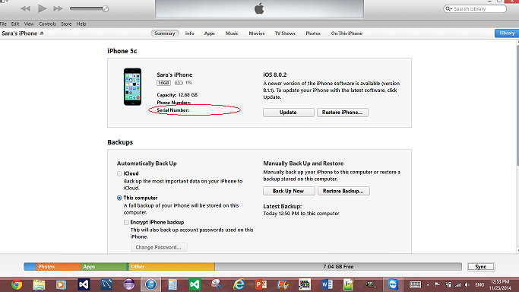

1. Click on the Serial Number (It does not look clickable but it is) to cycle through the number

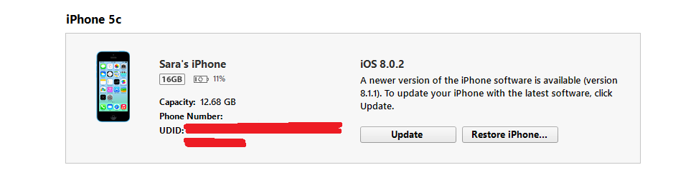

1. Copy and paste your UUID and send it to your Team Admin to add you to the provisioning profile

# Running Project as Simulator

You do not need a Developer account, code-signing certificate, provisioning profile, device, or your device’s UUID to use the simulator!

1. Set the Product->Destination and set it to a simulator

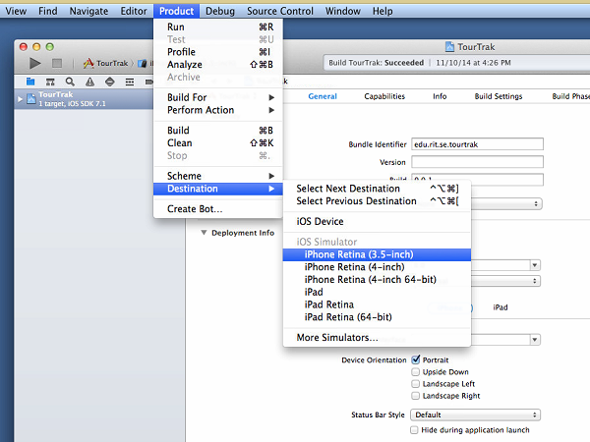

1. Use Product-> Run

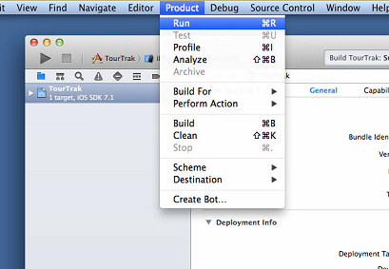

1. To remove the app from the simulator
   1. Stop the app

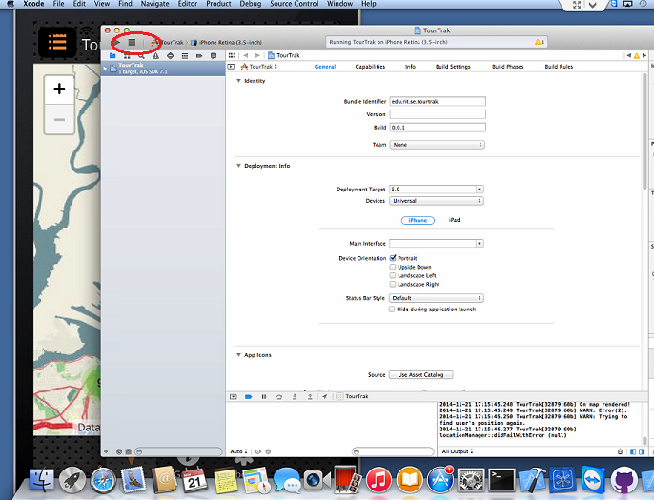

* + 1. To clear the entire simulator of *all* new apps, go iOS Simulator-> Reset Content and Settings

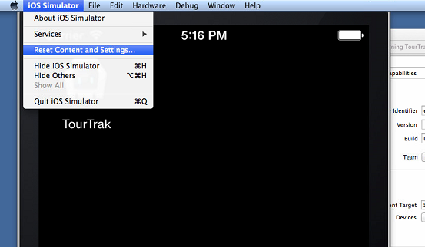

* + 1. To remove *only one* app,
       1. Hold mouse down on icon to enter “Jiggle mode”

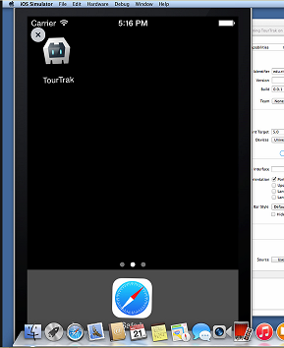

* + - 1. Click the “X”
      2. To escape Jiggle Mode, go to Hardware->Home

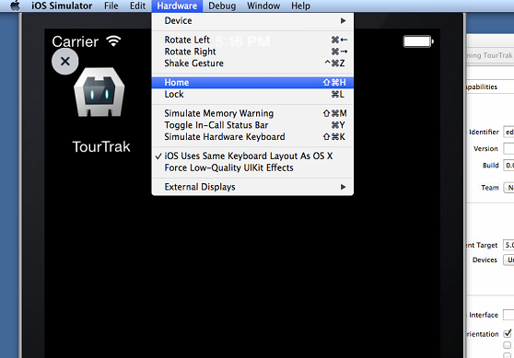

# Running Project on Device

You will need a Developer account, code-signing certificate, provisioning profile, device, or your device’s UUID to run on a device.

1. Make sure your device's UUID is registered in the Apple Developer's Member's Center.
2. Refresh the provisioning profile if it has just been added.
   1. To do this, open Xcode->Preferences.

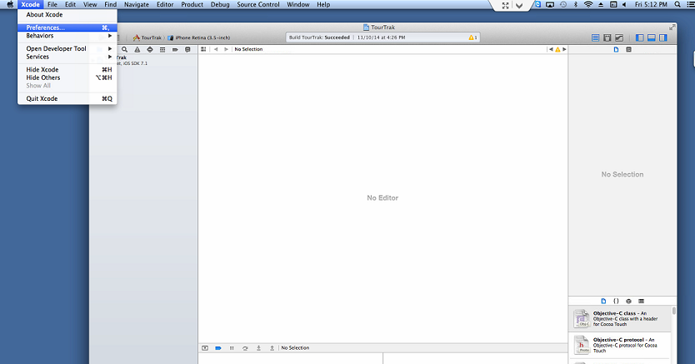

* 1. Click "View Details."

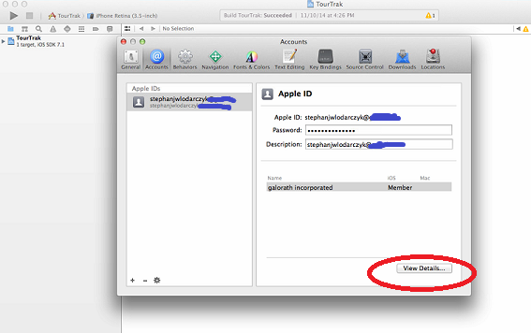

* 1. Click on the provisioning profile you wish to refresh and then the refresh button.

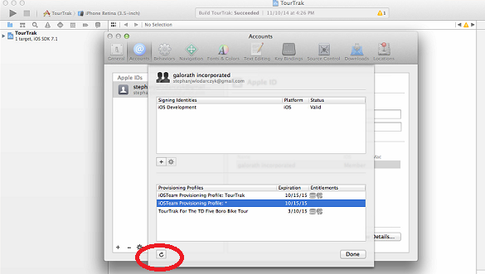

1. Make sure bundle identifier (in General Settings), provisioning profile, and code-signing identities are set (both in the Build Settings)

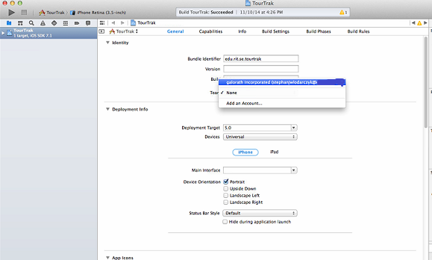

1. Connect your device to the MAC. Make sure it and Xcode is up-to-date.
2. Set Product->Destination to your device's name. (If it says “iOS Device,” your device is not connected.)

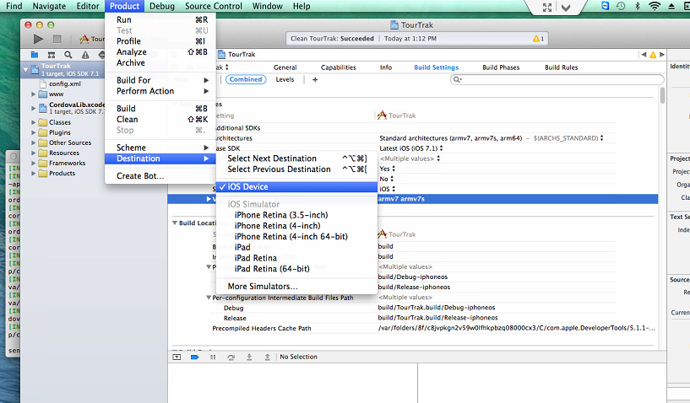

1. Product-> Run



1. To remove the app from your device, press the app icon until the phone goes into "jiggle mode." Press the X in the corner.

# Beta Testing with Test Flight

iOS apps are typically distributed through the App Store or deployed from a Mac to the device. However TestFlight allows you to deploy to users without going through the App Store or connecting directly from the computer. You can manage your team and builds through <https://www.testflightapp.com> and use the desktop app to upload your build. You will need the UUID of every device that will be testing and will need to refresh the provisioning profile in Xcode. You will also need to create an IPA file to upload to TestFlight.

# Creating IPA file

You will need a Developer account, code-signing certificate, provisioning profile, device, or your device’s UUID to run on a device.

1. Open Xcode project. (If you are working on the TourTrak project, it is located in /devcycle-mobile-app/cordova/platforms/ios
2. Make sure bundle identifier (in General Settings), provisioning profile, and code-signing identities are set (both in the Build Settings) (Please refer to the “Run on Device” section for additional instructions.)
3. Set Product->Destination to “iOS Device”. (No devices should be connected at this time.)
4. Product->Archive

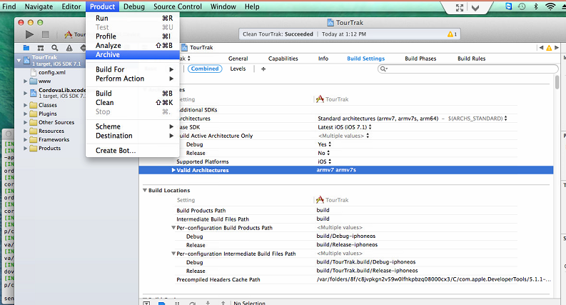

1. Open Window->Organizer if did not open automatically.

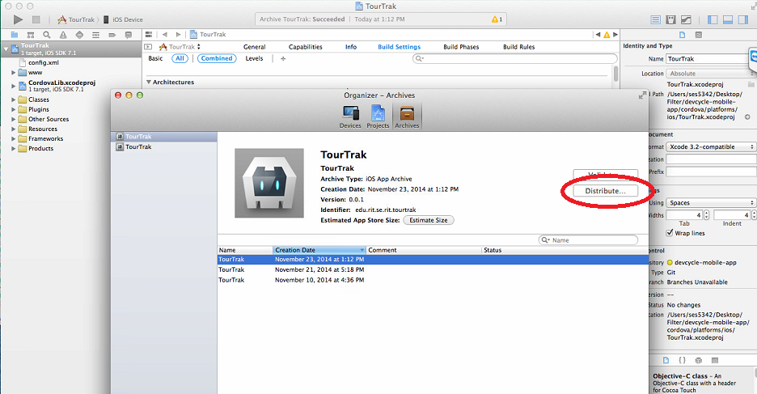

1. Distribute using the proper provisioning profile



1. Save in a place of your choosing.

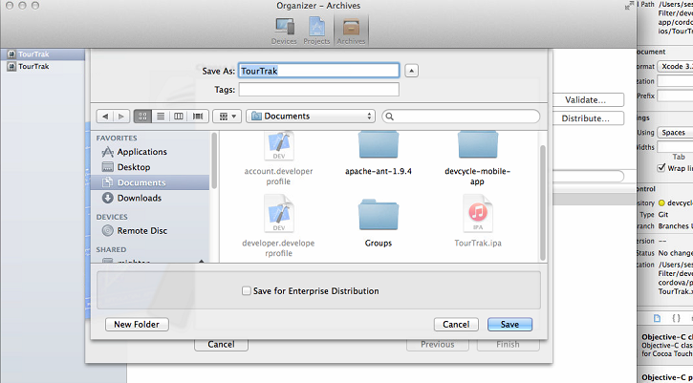

# Uploading to Testflight

1. Open TestFlight Desktop app (Alternately, you can upload your IPA using the website)

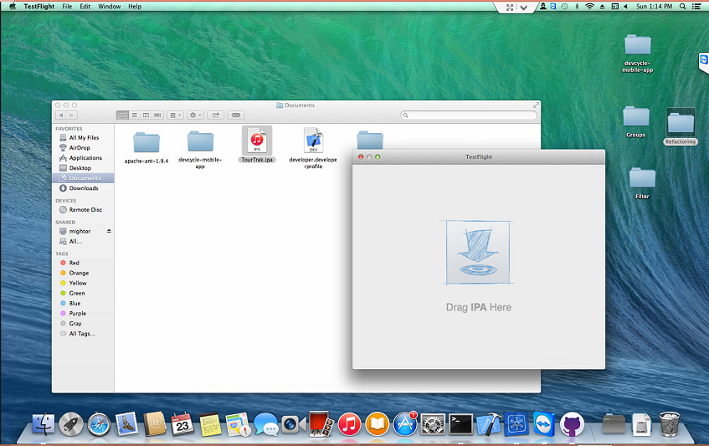

1. Drag IPA file into the window.

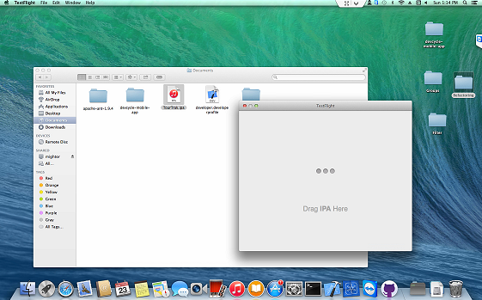

1. Add an optional comment

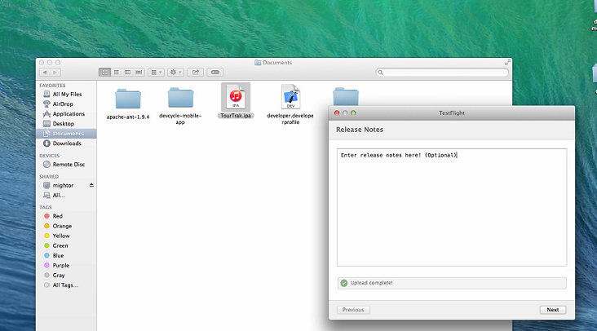

1. Select the users you wish to notify and hit submit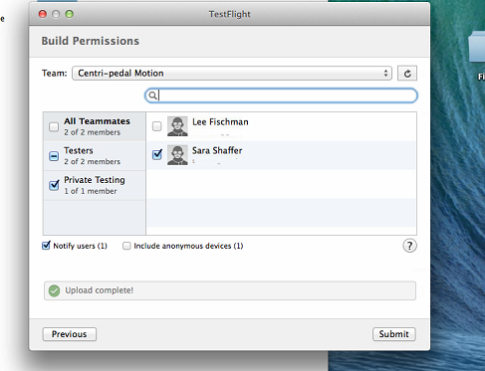
2. Your testers can access the build via their email or the TestFlight iOS app.

# Creating a TestFlight Team

1. Make sure all devices that will be testing are registered in the Apple Developer Member's Center and that the provisioning profile has been refreshed if they have just been added. (To do this, open Xcode->Preferences. Click "View Details." Click on the provisioning profile you wish to refresh and then the refresh button.)
2. Invite your Team Members
3. Set Build Permissions

# iOS 8 Location Services

The iOS 8 update contained some significant changes to Location Services. Apps that use Location Services can either track while the app is open (the default) or while it is in the background (what older iOS versions did.) This provides the user with more privacy but affects the functionality of certain applications. To change from the default, there are some special things developers must do.

1. Setting the p-List.
   1. Find a .plist file under Resources in your project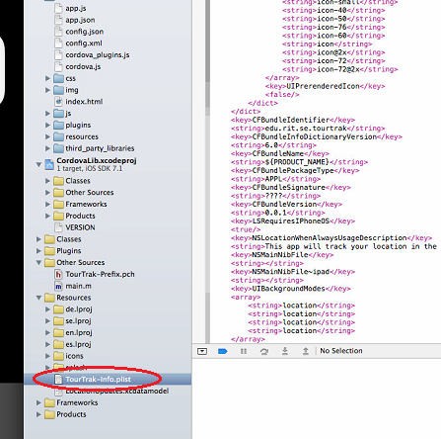
   2. Right click-> Open As -> Source Code (This is optional but might be easier to edit.)

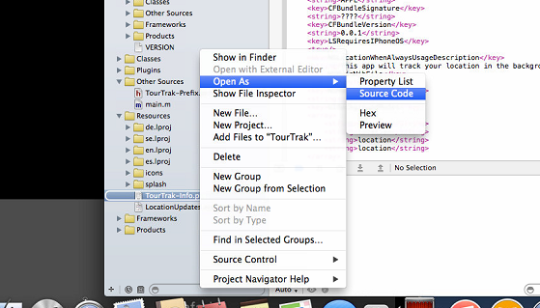

* 1. Find the NSLocationWhenInUseUsageDescription and change to NSLocationAlwaysUsageDescription and add an optional string. 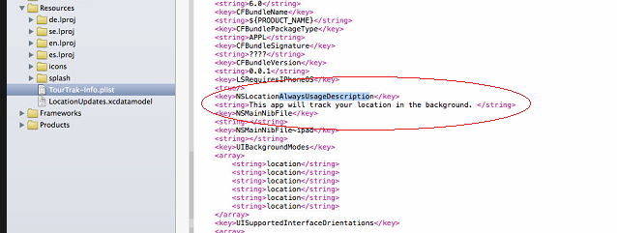
  2. The optional string will appear on the permission alert.

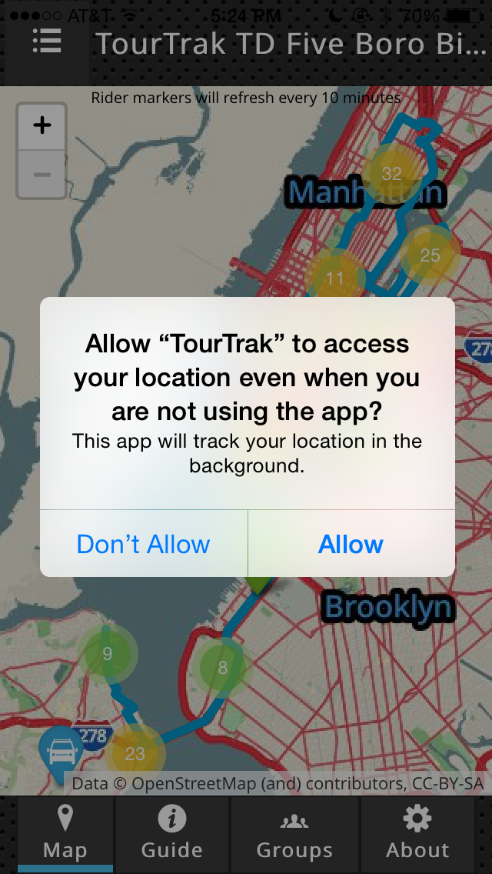

1. Add [self.locationManager requestAlwaysAuthorization]; after #ifdef_PHONE_8.X in the startLocation function in CDVLocation.m.

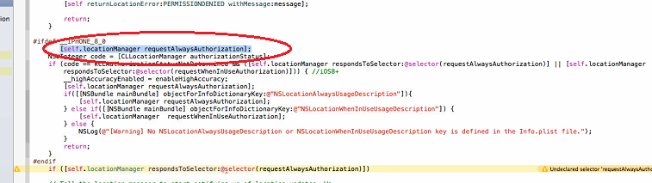

1. It is possible for your user to not select any options for Location Services. This is considered “UnDetermined.” If this should not be an option, add [self.locationManager requestAlwaysAuthorization]; under the first conditional statement.

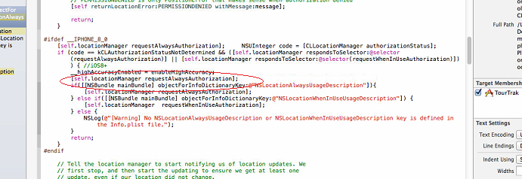

# Adding Icons and Splash Screen

Add icons (App, Spotlight, and Settings) and splash screen (Launch Image)

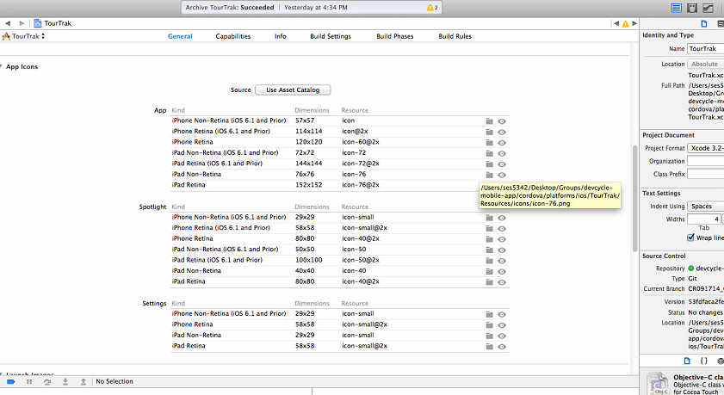

1. Go to General->App Icons

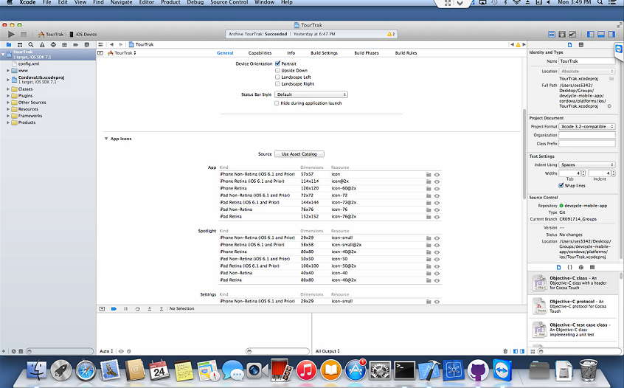

1. Click on Folder Icon and select your icon. Be sure the icons are the correct dimensions

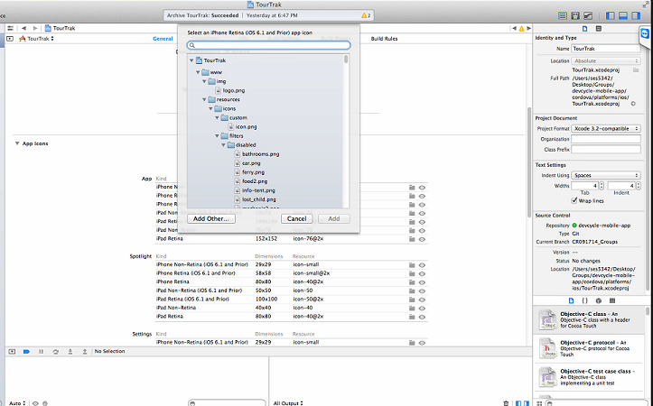

# Trouble Shooting

## Linker Errors on Archive

You have tried to archive your app and then this happens. It fails and produces several linker errors.

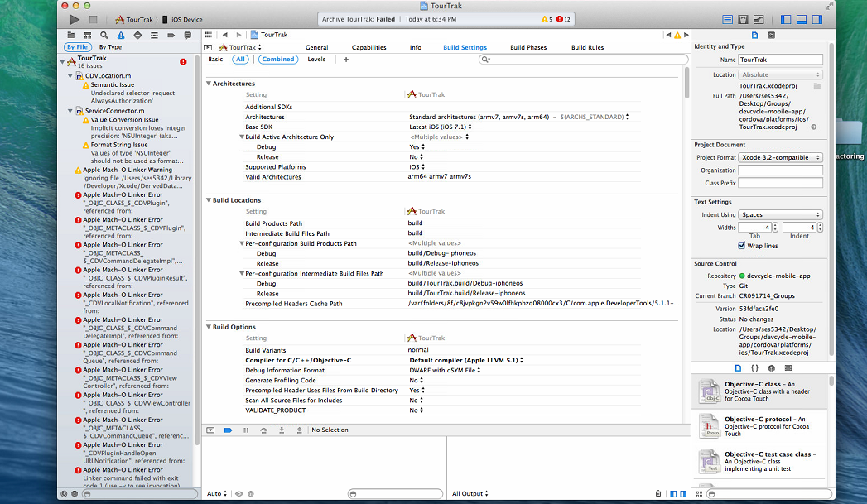

A possible solution is to remove arm64.

1. Go to Build Settings -> Architectures. Click on the valid architectures to get the drop down

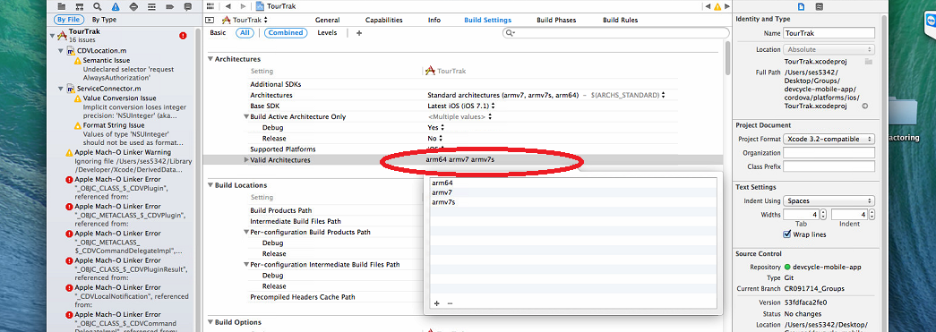

1. Remove arm64
2. Click on arm64 (1)
3. Click the minus sign (2)

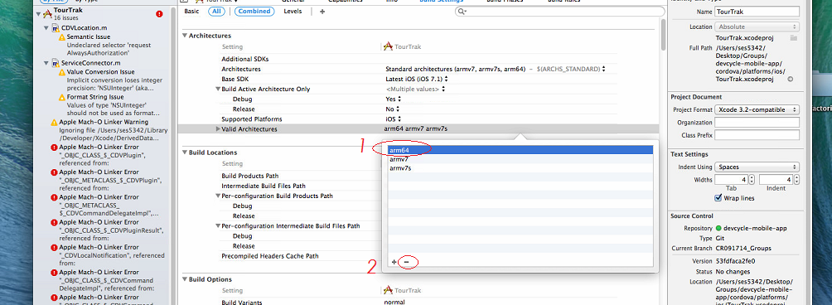

1. Hit enter

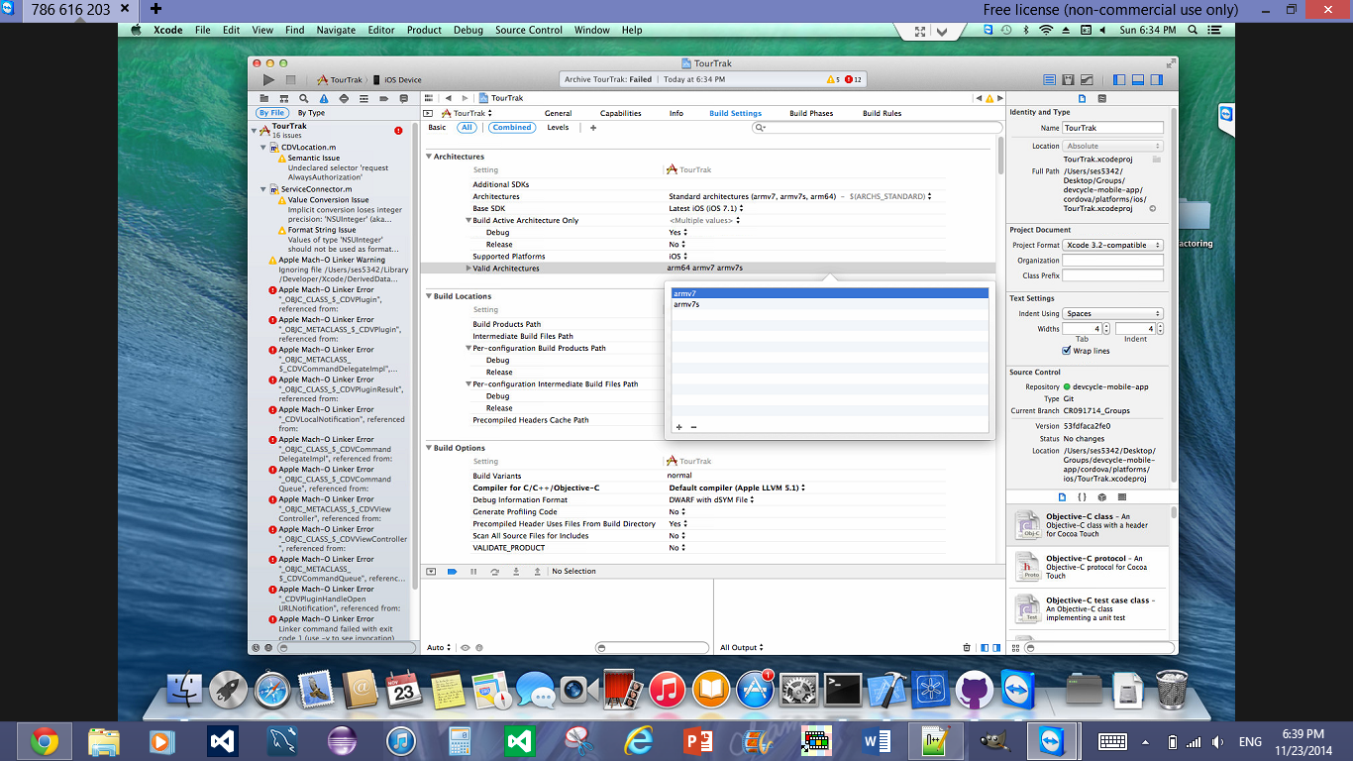

1. Clean the project by Product-> Clean

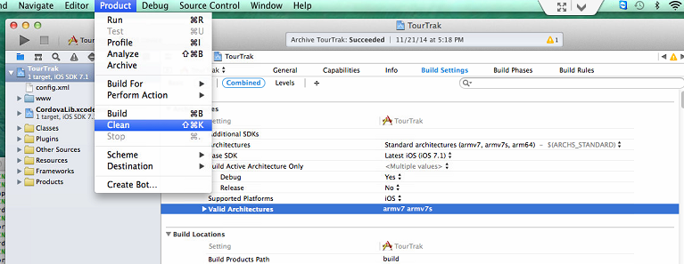

## Pop-up with a path name requests Location Services

After your application asks your permission to use Location Services, did you get this second pop-up with a not user-friendly message?

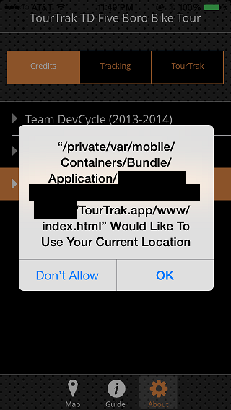

This is caused when using Apache Cordova and iOS Location Services. It can be caused by a couple of things. I suggest looking at [this question.](http://stackoverflow.com/questions/1673579/location-permission-alert-on-iphone-with-phonegap) It comes from the device not being ready before the geolocation services begin and is linked to the Safari web browser, the default browser on iOS. Here are three different solutions:

1. In the app.json file and within the “js” brackets, check that “cordova.js” is called first *and only once*. Cordova.js cannot be called after any other files (including itself.) This may have been caused by a merge error, so take care when performing merges with this file.
2. Use a “deviceOnReady” function to be sure the device is ready before Geolocation starts.
3. Make sure the Geolocation plugin has been installed. (Check the plugins folder in your cordova folder.)

## Icons are not setting

You are trying to add an icon image and it will not set. The solution is to make sure the icons are the *exact* dimensions. The dimensions are listed next to their type. Resize them accordingly with your favorite image editor. Apple’s default Preview application can resize images. (Be sure to deselect “Scale Proportionally.” The icons will not be the correct size.)

# Glossary

App Store- Where iOS apps are distributed to the users

App icon- The icon representing the app on the device

Code Signing Certificate- Signs the code to ensure that a trustworthy team member changed the code

IPA- the archive file where an iOS app is stored

Member Center- Go to (<https://developer.apple.com/>) and click Member Center and sign in with your Developer Account credentials. Here the Team Agent and/or Team Admin can manage developers, devices, and certificates.

Provisioning Profile- Manages all the devices and users who can install the app on their device

Setting icon- The icon shown in the settings application

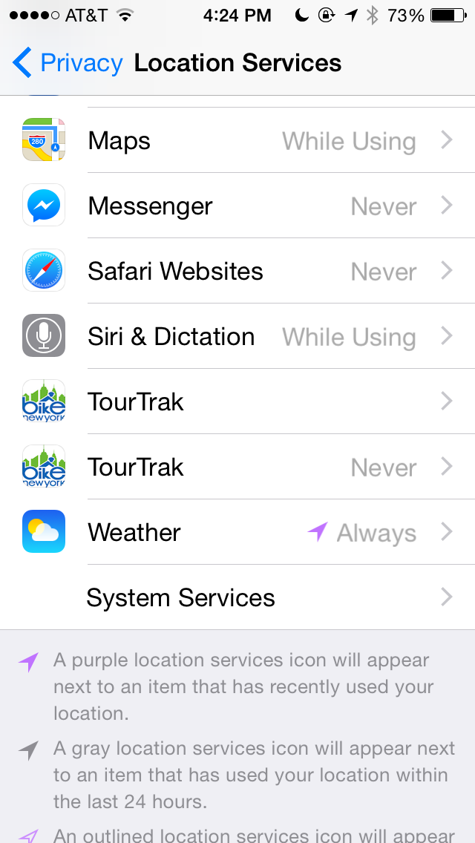

Splash Screen/Launch Image- An image that pops up while your app loads. This gives the user the illusion your app is faster than it really is.

Spotlight icon- The icon shown while the app is installing.

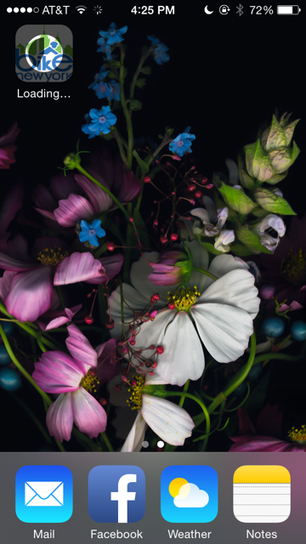

TestFlight- (<https://www.testflightapp.com>) A beta testing site that allows you to distribute apps to your sponsor without deploying to the App Store

UUID- The unique identifier of your device

Xcode- the IDE for iOS development